here are information from <https://www.osha.gov/etools/computer-workstations/positions>， This an official website of the United States government , U.S. department of labor, occupational safety and health Administration.

* [Home](https://www.osha.gov/) ->[eTools](https://www.osha.gov/etools" \o "eTools) ->Computer Workstations : Positions

#### [Computer Workstations](https://www.osha.gov/etools/computer-workstations) » Good Working Positions

To understand the best way to set up a computer workstation, it is helpful to understand the concept of neutral body positioning. This is a comfortable working posture in which your joints are naturally aligned. Working with the body in a neutral position reduces stress and strain on the muscles, tendons, and skeletal system and reduces your risk of developing a musculoskeletal disorder (MSD). The following are important considerations when attempting to maintain neutral body postures while working at the computer workstation:

* *Hands*, *wrists*, and *forearms* are straight, in-line and roughly parallel to the floor.
* *Head* is level, forward facing, and balanced. Generally it is in-line with the *torso*.
* *Shoulders* are relaxed and *upper arms* hang normally at the side of the body.
* *Elbows* stay in close to the body and are bent between 90 and 120 degrees.
* *Feet* are fully supported by the floor or a footrest may be used if the desk height is not adjustable.
* *Back* is fully supported with appropriate lumbar support when sitting vertical or leaning back slightly.
* *Thighs* and *hips* are supported and generally parallel to the floor.
* *Knees* are about the same height as the hips with the *feet* slightly forward

Regardless of how good your working posture is, working in the same posture or sitting still for prolonged periods is not healthy. You should change your working position frequently throughout the day in the following ways:

* Make small adjustments to your chair or backrest.
* Stretch your fingers, hands, arms, and torso.
* Stand up and walk around for a few minutes periodically.
* Perform some of your tasks in standing: computing, reading, phone, meetings.

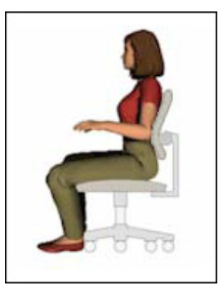

These four *reference postures* are examples of body posture changes that all provide neutral positioning for the body.

